|  |
| --- |
| **Digital and Logic Design** |
| Date: November 02nd 2024 |
| **Course Instructor(s)** |
| Muhammad Adeel |

|  |  |
| --- | --- |
| **Sessional II Exam** | |
| **Total Time (Hrs):** | **1** |
| **Total Marks:** | **120** |
| **Total Questions:** | **4** |

|  |
| --- |
| _____________________ _____________________  Roll No Section Student Signature |

|  |
| --- |
| **Vetted by: Signature: .** |

**Do not write below this line**

|  |  |
| --- | --- |
| **Instruction/ Notes** | * **Attempt any all questions** * **Read each question carefully; marks will be deducted for not meeting the requirements.** * **Only Scientific Calculators are permitted during the Examination** * **Marks for each question are indicated alongside the question.** * **Lead pencils are not permitted during the examination.** * **Understanding the part of the paper, you are not allowed to disturb the invigilator to seek any help.** |

|  |  |  |  |
| --- | --- | --- | --- |
| **Q1** | **Q2** | **Q3** | **Q4** |
| **CLO 1** | **CLO 1** | **CLO 1** | **CLO 1** |
| **30** | **30** | **30** | **30** |
|  |  |  |  |

***CLO # 1: Apply Binary Logic, Boolean Algebra, and Karnaugh map Methods to calculate and simplify Boolean functions***

**Q1: (Use the Last page for rough work, perform all calculations, and write a neat and clean answer in the provided space) [30 marks]**

**Apply the Karnaugh map on the Boolean function “F”, together with the don’t care conditions “d” and find the simplified POS equation:**

**F(A,B,C,D)= ∏(0,6,8,10,13), F(𝐴, 𝐵, 𝐶, 𝐷) = Σ(1,3,5,7,9,11,12,15) and d(𝐴, 𝐵, 𝐶, 𝐷) = Σ(0,2,4,6,8,10,13)**

**CD**

|  |  |  |  |
| --- | --- | --- | --- |
|  |  |  |  |
|  |  |  |  |
|  |  |  |  |
|  |  |  |  |



**AB**

***Equation with all possible step:***

F`=

F =

***CLO # 02: Use digital circuit-solving techniques to obtain truth tables, Boolean functions, and timing diagrams for combinational circuits, and State equations, state tables, and state diagrams for sequential circuits.***

**Q6:** **(Use the Last page for rough work, perform all calculations, and write a neat and clean answer in the provided space. If part a is wrong part b and c rewarded as zero)** **[30 marks]**

**A circuit takes four inputs: 𝒂, 𝒃, 𝒄, 𝒂𝒏𝒅 𝒅.The three inputs 𝒂, 𝒃, 𝒂𝒏𝒅 𝒄 represent the binary digits of the**

**number (0-7), with 𝒂 being the most significant bit. 𝒅 is an odd-parity bit, meaning it ensures that the total number of 1s 𝑖𝑛 𝒂, 𝒃, 𝒄, 𝑎𝑛𝑑 𝒅 is always odd. The circuit outputs 1 if the input number is a prime number, and 0 otherwise. A prime number is a number divisible only by itself and 1. 1 is considered prime, but 0 is not. Apply don’t care carefully.**

* **Implement the truth table for the above circuit [20 marks]**
* **Implement the K-map for the truth table [5 marks]**
* **Draw the circuit diagram using nor gates. [5 marks]**

|  |  |  |  |  |
| --- | --- | --- | --- | --- |
| **a** | **b** | **c** | **d** | **F** |
|  |  |  |  |  |
|  |  |  |  |  |
|  |  |  |  |  |
|  |  |  |  |  |
|  |  |  |  |  |
|  |  |  |  |  |
|  |  |  |  |  |
|  |  |  |  |  |
|  |  |  |  |  |
|  |  |  |  |  |
|  |  |  |  |  |
|  |  |  |  |  |
|  |  |  |  |  |
|  |  |  |  |  |
|  |  |  |  |  |
|  |  |  |  |  |

|  |  |  |  |
| --- | --- | --- | --- |
| **c d** |  |  |  |
|  |  |  |  |
|  |  |  |  |
|  |  |  |  |

**For F**

**a b**

**Implement the circuit diagram using NOR Gates**

***Equation with all possible step:***

F=

**a______**

**b_______**

**__F**

**c________**

**d________**

***CLO # 02: Use digital circuit-solving techniques to obtain truth tables, Boolean functions, and timing diagrams for combinational circuits, and State equations, state tables, and state diagrams for sequential circuits.***

**Q6:** **(Use the Last page for rough work, perform all calculations, and write a neat and clean answer in the provided space. If part a is wrong part b and c rewarded as zero)** **[30 marks]**

Design a Combinational circuit for the problem statement given below. Problem statement: Consider a machine with 4 bits (A3, A2, A1 and A0) as inputs. If the decimal equivalent of **A2A1A0 is even** and **A3 is ‘0’** or the decimal equivalent of **A3A2A1 is odd** and **A0 is ‘X’** the machine gives the **output as ‘1’** otherwise it outputs ‘0’. For this machine A3 is the MSB and A0 is the LSB. (Hint: If 1011 is the input then the output is 1 because A3A2A1 is 101 which is 5).

* 1. **Draw the truth table [20 Marks]**
  2. **Derive a simplified Boolean expression using K-Map [5 Marks]**
  3. **Implement the circuit diagram using NAND gates [5 Marks]**

|  |  |  |  |  |
| --- | --- | --- | --- | --- |
| **A3** | **A2** | **A1** | **A0** | **F** |
|  |  |  |  |  |
|  |  |  |  |  |
|  |  |  |  |  |
|  |  |  |  |  |
|  |  |  |  |  |
|  |  |  |  |  |
|  |  |  |  |  |
|  |  |  |  |  |
|  |  |  |  |  |
|  |  |  |  |  |
|  |  |  |  |  |
|  |  |  |  |  |
|  |  |  |  |  |
|  |  |  |  |  |
|  |  |  |  |  |
|  |  |  |  |  |

|  |  |  |  |
| --- | --- | --- | --- |
| **A3A2** |  |  |  |
|  |  |  |  |
|  |  |  |  |
|  |  |  |  |

**for F**

***Equation with all possible step:***

O=

**Implement the circuit diagram using NAND Gates**

**A1A0**

***CLO # 02 : Use digital circuit-solving techniques to obtain truth tables, Boolean functions, and timing diagrams for combinational circuits, and State equations, state tables, and state diagrams for sequential circuits***

**Q4:** (**Use the Last page for rough work, perform all calculations, and write a neat and clean answer in the provided space)**  [30marks]

1. 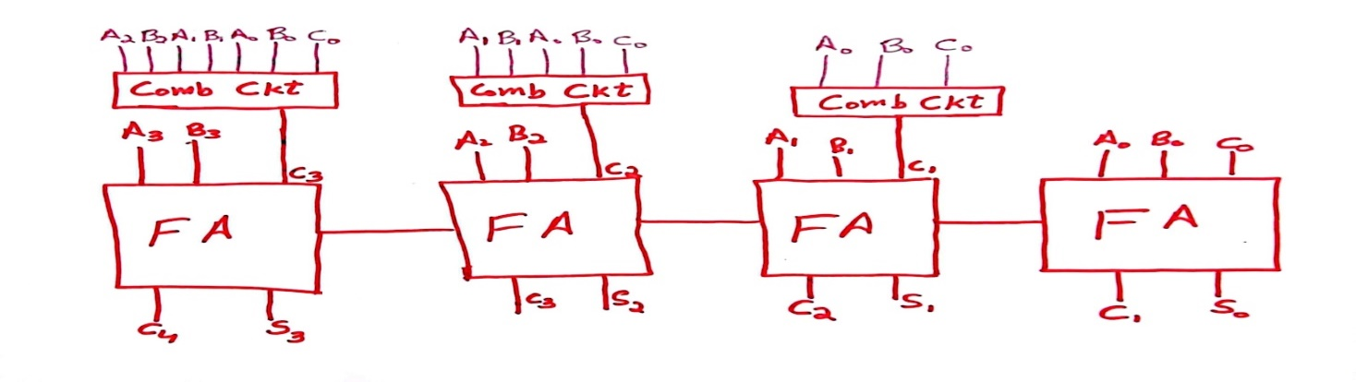**Following figure shows a Carry Look Ahead Adder which can be designed from four (4) full adder. Addition of 4-bit number using parallel adder is difficult due to delay in the circuit. This can be overcome with the help of carry look ahead adder circuit. In this question you are required to add the below 4-bit number by using the Carry Look ahead adder shown below.**

**Note: Write complete formula of every carry in signle line. Calculate it in rough work**

|  |
| --- |
| * 1. **The value of A is “0110” and B is “1001” [15 marks]**   **Sum**  **Carry** |
| * 1. **The value of A is “1111” and B is “1011” [15 marks]**   **Sum**  **Carry** |

**Page for Rough work**